Project Edulead

**USER MANUAL**

**Student Lifecycle Management System**

**Module-Admission**

**February 2021, Version 1.0**

**Sustainable Outreach and Universal Leadership Limited**

**Sign off Date Signature Client Signature Consulting**

Table of Contents

About this Manual 3

Education Configuration 4

Module 1: Admission 5

1. Masters 5

1.1 Departments 5

1.2 Level 6

1.3 Class 8

1.4 Subject 9

1.5 Section 11

1.6 Classroom 11

2. Student & Teacher: 13

2.1 Student 13

2.2 Teacher 16

2.3 Guardian18

2.4 Student Categories 20

2.5 Student Batch 22

3. Admission Masters23

3.1 Document Template 23

3.2 Academic Events 24

3.3 Academic Calendar Template 25

3.4 Eligibilty Paramter 26

3.5 Academic Year 27

4. Application and Enrollment 28

4.1 Student Admission 28

4.2 Student Applicant 29

4.3 Class Enrollment 31

4.4 Subject Enrollment 33

5. Fees 33

5.1 Fee Structure 33

5.2 Fee Schedule 35

5.3 Fee Category 36

5.4 Fees 36

6. Tools 38

6.1 Student Reregistration Tool 38

# About this Manual

This User Manual acts as a reference for ERP- EduLead by describing its various concepts and abilities, and by leading the user through the basics of EduLead software. It also provides a detailed reference for all of the EduLead SLCM (Student Lifecycle Management) functionalities.

The User Manual describes all the processes and functionalities regarding various modules and its abilities to conduct the smooth transactions and integrations within the modules.

The software EduLead is an open-source, easy to use and customize, actively maintained, economical and well supported.

Throughout this manual it is assumed that the reader has a working knowledge of about Student Lifecycle Management and basic computer skills and knows how to:

* Use keyboard and mouse
* Use web browsers to access the EduLead website
* Locate, open and save data files.
* Edit, cut, paste and text.

The SLCM consists of 3 Modules mainly:

1. Admission
2. Academics
3. Examination

This User Manual consists of the **Admission Module** for End User reference and guidance. The manual describes how to use the Standard interface. As mentioned, it contains instructions that the users must follow during the operation and servicing of **EduLead**. Diverting from the workflow as mentioned in the user manual may result in errors and non-functioning of the software EduLead. It is advisable that the end users must abide by the instructions as mentioned in the user manual.

# Education Configuration

The Education Configuration will allow you to do a basic setup for your Institute wherein you can define the Student Registration Naming for Admission process, Seat Reservation based on Category, Exam Fees and other defaults for your EduLead account.

These configuration settings will have an impact throughout the module.

To access Academic term, go to:

Home > School-Admission > Settings > Education Configuration

#### Steps to configure Education Settings

* + - 1. Select the current Academic Year format such as academic year.-.#####. This will become the default Naming Options for Student Registration Naming.

Naming Options can be defined in various ways such as:

* **field: [fieldname]** - By Field
* **naming_series:** - By Naming Series (field called naming_series must be present
* **Prompt** - Prompt user for a name
* **[series]** - Series by prefix (separated by a dot); for example, PRE.#####
* **format: MM.-.fieldname1.-.{#####}** - Replace all braced words (fieldnames, date words (DD, MM, YY), series) with their value.

1. Select the Seat Reservation based on Category. This will become the various categories based on which Admission shall be conducted.
2. The Categories that can be implemented are:

* Student Category

1. Select if Exam Fees applicable or not

# Module 1: Admission

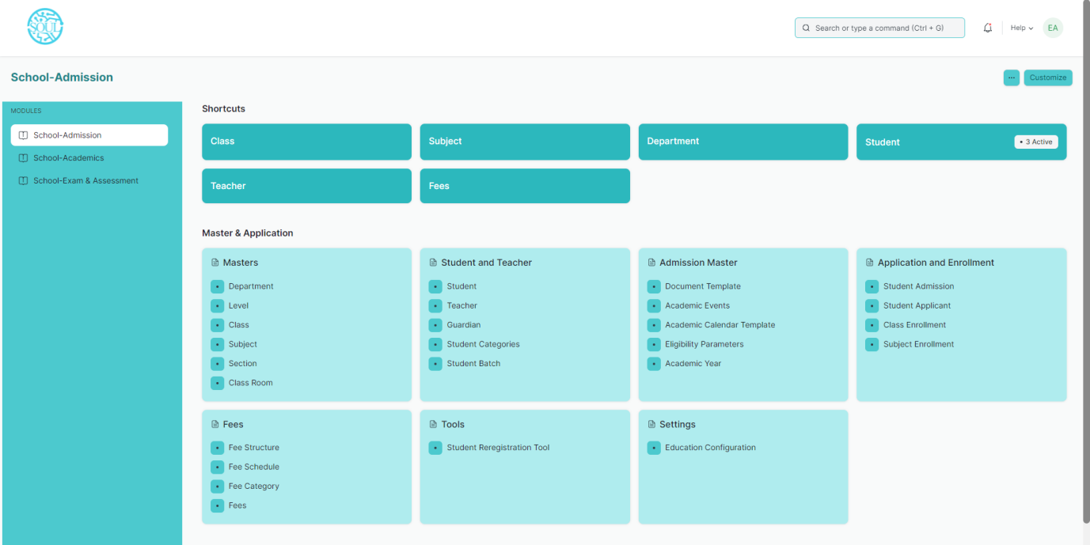

## Masters

### Department

**A Department is a specialized functional area or a division within an organization.**

You can configure the Departments in your organization, set Leave Block List, and also Leave and Expense Approvers for the same.

To access Department, go to:

Home > School-Admission > Masters > Department

Department is a tree-structured master, which means you can create parent departments and sub-departments as shown below:

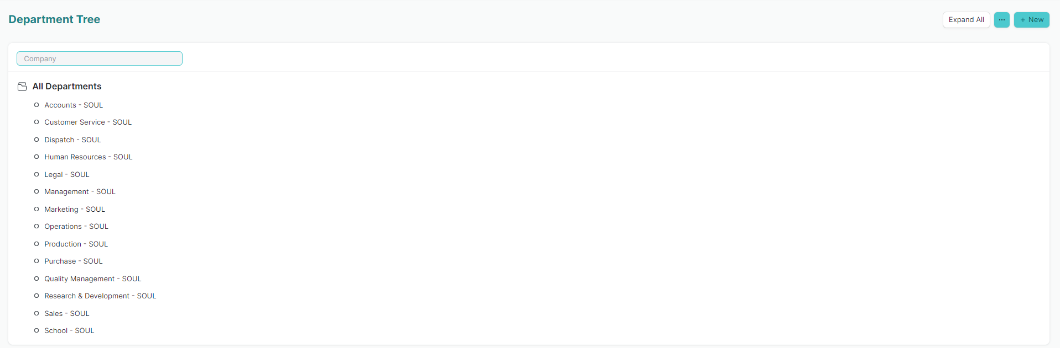

#### Prerequisites

Before creating a Department, it is advisable you create the following documents:

* Company
* Leave Block List

#### How to create a Department?

1. Go to the Department list, click on New.
2. Enter Department name.
3. Select Company name.
4. Select “Is Group” and “Is Stream” if there are any child department under the parent department.
5. Select Leave Block List (optional) applicable for this department.
6. Save.

### Level

A Level is a resemblance of Master Class where all the classes in a school are grouped together. This helps us from creating any duplicate classes.

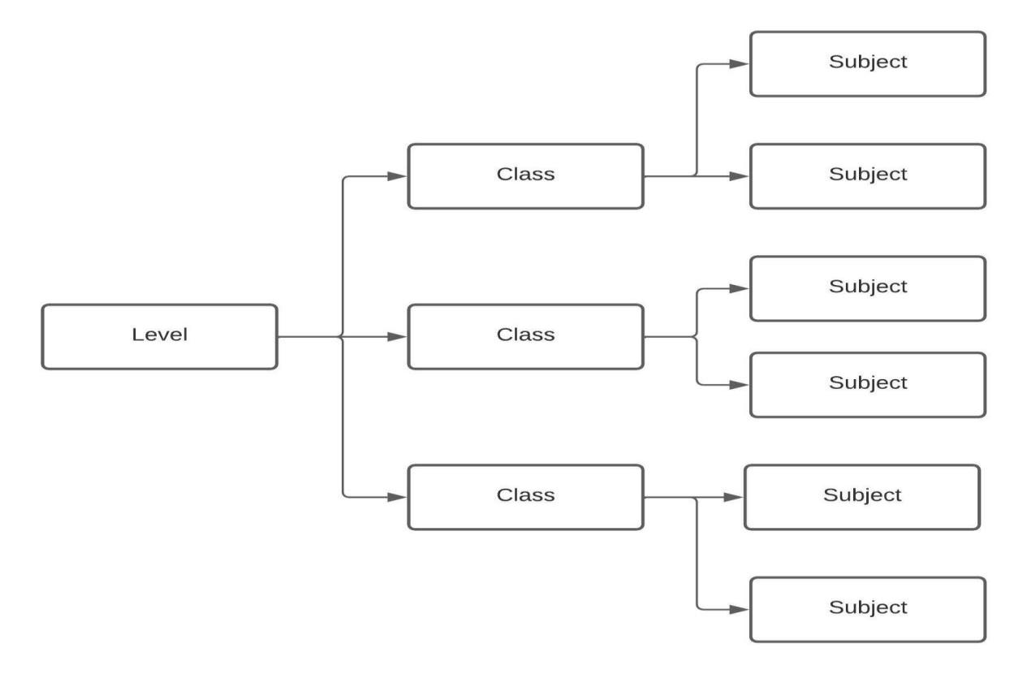For example, Master Class would be a Level for all the different classes that will have various subjects within.

To access the Level list, go to:

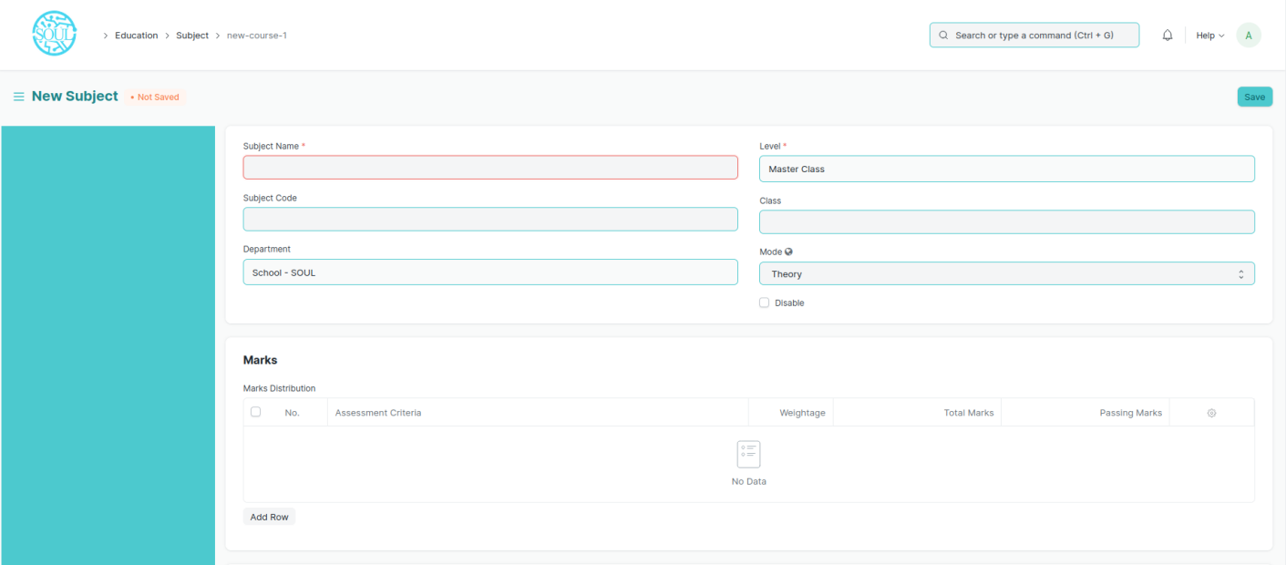Home > School-Admission > Masters > Level

#### Prerequisites

To create a New Level, it is advised to create the following first:

1. Department

#### How to create a new Level?

1. Go to the Level list and click on New.
2. Enter the Level Name and the Creation Date.
3. Select the Department for the Class.
4. Enter total number of classes.
5. Save.
6. Click on the “Add Classes” button and all the Classes will be created.

*Description: Add the description of the Level which you want to be visible on the portal*.

*Note: Level can be created only once, As duplicate classes cannot be created*.

### Class

A Class is individual part of a Level.

To go to Class, go to:

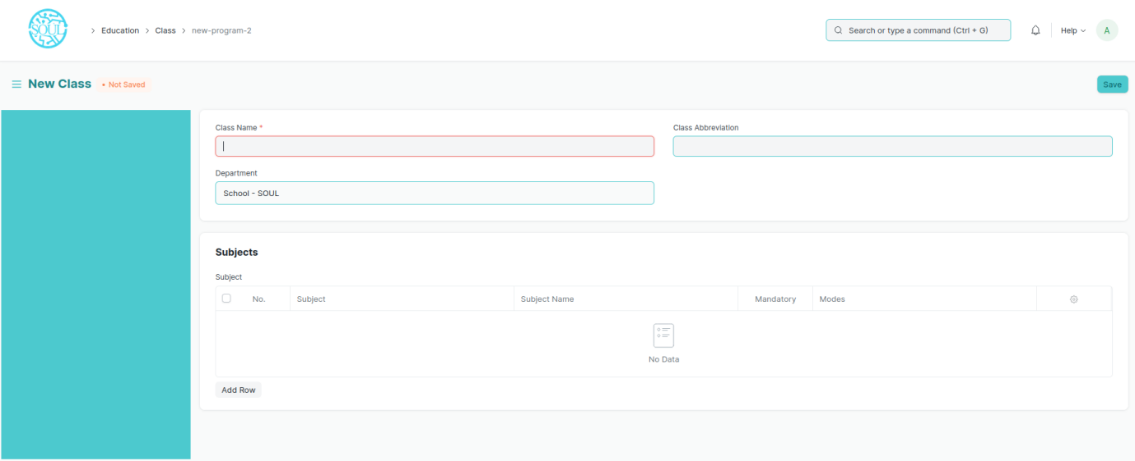Home > School-Admission > Masters > Class

#### Prerequisites

To create a New Semester, it is advised to create the following first:

* + - 1. Level

#### How to create a new Class?

1. Method 1:
   1. Upon saving the Level we can add Class in the Class table and save the Class.
   2. The Class get automatically saved and linked with the respective Level.
2. Method 2:
   1. Go to the Class list and click on add Class.
   2. Enter the Class Name and Class Abbreviation.
   3. Select and add Subjects if required.
   4. Save

### Subject

A Subject is a part of an educational Class which is to be taught for a term.

For example, if for a particular year in Class I, Mathematics would be a Subject covered under the Class.

A Subject will have a set of topics that are to be covered under its scope.

To access the Subject list, go to:

Home > School-Admission > Masters > Subject

#### Prerequisites

Before creating a Subject, it is advised to create:

1. Department
2. Class
3. Level
4. Assessment Criteria
5. Topics

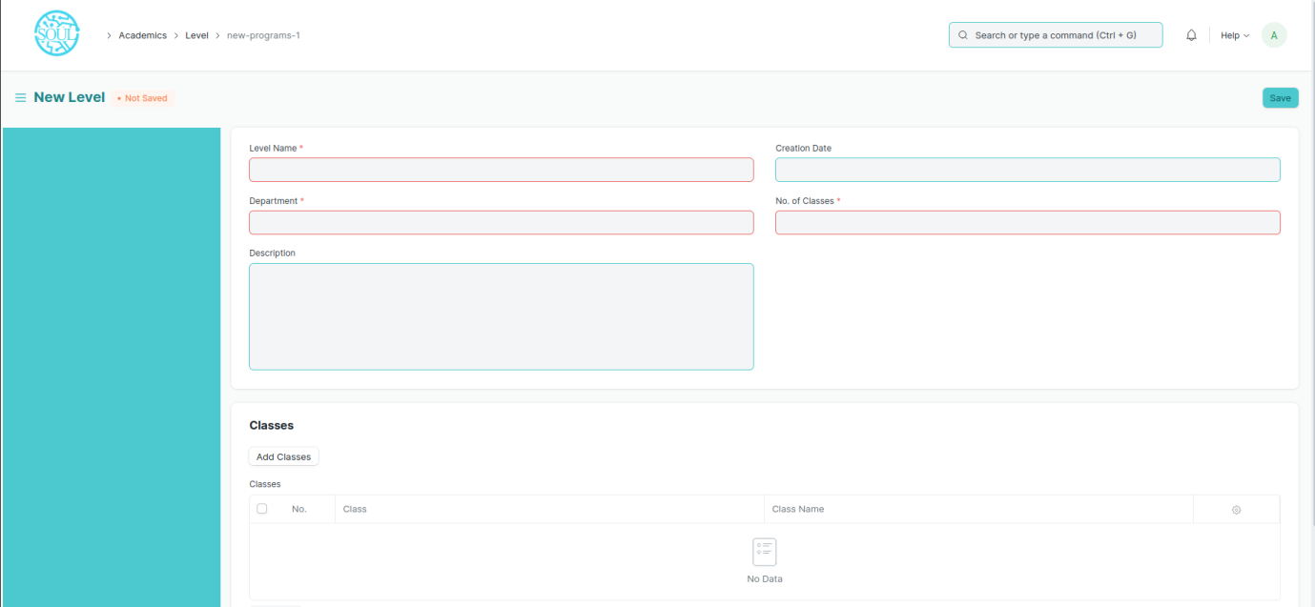

#### How to create a Subject?

1. Go to Subject List and click on New.
2. Enter the Subject Name, Subject Code.
3. Select the Department and Class under which this Subject is being made.
4. Add the Assessment Criteria, weightage, Total marks and Passing marks. You can also create the Assessment Criteria from here itself.
5. Add the Topics. You can also create the topics from here itself.
6. Add the Description for the Subject.
7. Save.

#### More Actions

Once the Subject has been created, the following documents can be created from the Subject, which will later be linked to the Subject.

* 1. Class
  2. Student Group
  3. Subject Schedule
  4. Exam and Assessment Processes

### Section

A Section is a partition of a class with similar or different number of students studying in the each of them. A Class can have different number of sections based on the strength of students in that class.

For example, Class I can have different sections like Section-A, Section-B, etc..

To access the section list, go to:

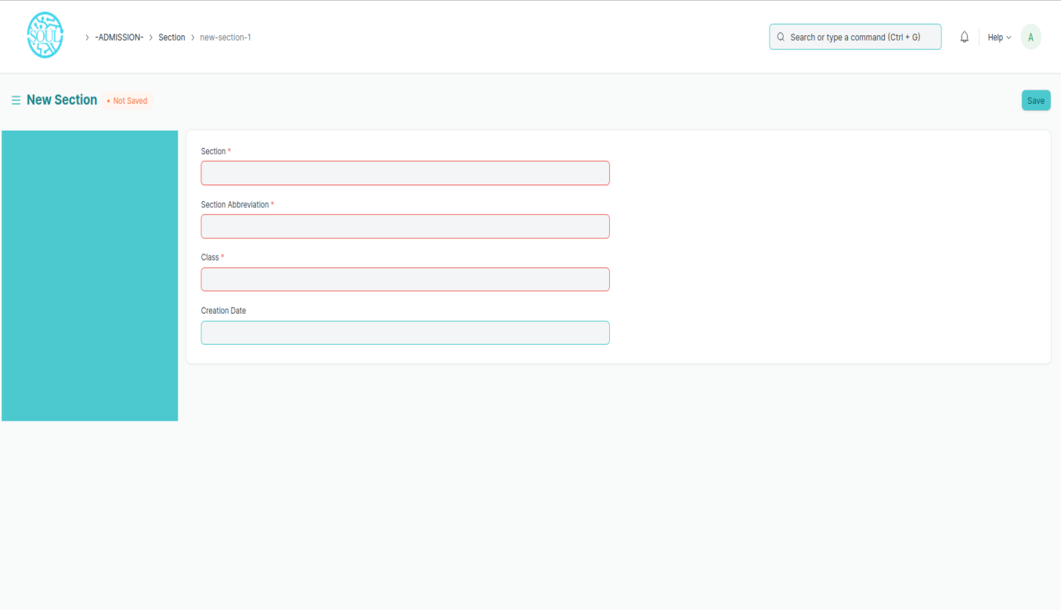Home > School-Admission > Masters > Section

#### Prerequisites

Before creating a Section, it is advised to create:

1. Class

#### How to create a Subject?

1. Go to Section List and click on New.
2. Enter the Section Name, Section Abbreviation.
3. Select the Class under which this section is being made.
4. Enter Creation Date.
5. Save.

### Classroom

Classroom refers to a tutoring space which can be set as the venue for Subjects or examinations.

Examples of a Classroom are Examination Halls, Classrooms, or Labs. The Room will have details like Room number and Room Capacity.

To access Room, go to:

Home > School-Admission > Masters > Classroom

#### C:\Users\priyt\Pictures\Screenshots\Screenshot 2022-02-23 125401.pngScreenshot 2022-02-23 125401

#### How to create a Room?

1. Go to the Room list and click on New.
2. Add the name of the room.
3. Add the Room Number for the selected room.
4. 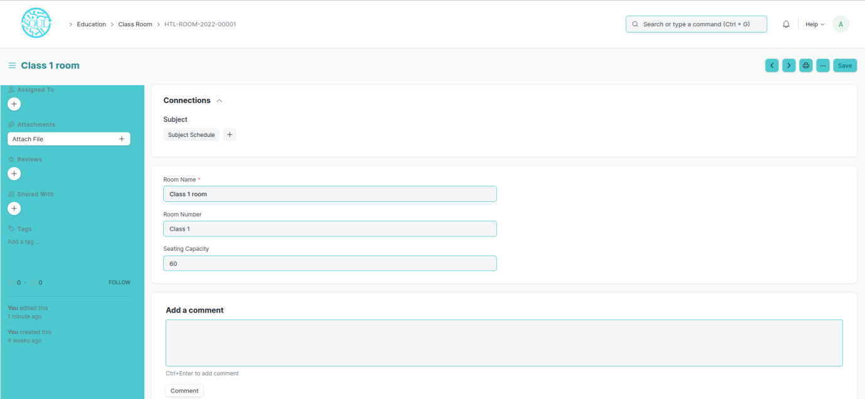Enter the Seating capacity for the room.

#### Other Actions

A Room can be further linked to a Subject Schedule.

## Student & Teacher

1. Student

The Student document will hold all the data of any Student in your Academy like their Personal Information, Photo, Date of Birth, Address, etc.

This form will also contain any additional details like the Student's Guardian and Sibling details.

The student is enrolled in a Class when the application is approved. Once the enrollment is done the Student Applicant status is update to Admitted.

To access Student, go to:

Home> School-Admission > Student & Teacher > Student

#### C:\Users\priyt\Pictures\Screenshots\Screenshot 2022-02-23 145122.pngScreenshot 2022-02-23 145122Prerequisites

Before creating a student, it is advised to create the following first:

* User (If Applicable)

#### C:\Users\priyt\Pictures\Screenshots\Screenshot 2022-02-23 145812.pngScreenshot 2022-02-23 145812How to create a New Student?

1. Go to the student list and click on New.
2. Enter the First Name, Middle Name and Last Name of the student.
3. Enter other details like Student Email Address, User ID (If Applicable) and Joining Date.
4. Save.

#### Features

Apart from the aforementioned details, some additional details of the student that can be captured are as follows:

1. **Personal Details**

Personal details of the Student like their Date of Birth, Gender, Blood Group, and Nationality can be added here.

1. **Home Address**

The address of the student, along with the City, State, and Pin code can be captured here. Two address lines can be captured for each student.

1. **Guardian Details**

The details of the student's guardian and their relationship with the student can be captured here. You can create a Guardian from here itself, or create a guardian first and then create the Student.

1. **Sibling Details**

This section will have all the details of the Student's Siblings. You can select if the sibling is studying in the Same Institute or no. If the Sibling is also a student of your institute, you will be required to enter their Student ID, if not, you can enter the name of the Institution they are associated with. Their academic details like Class and personal details like Gender and Date of Birth can also be captured.

1. **Exit Details**

The Student's exit details can be captured here, like their Date of Leaving, and Leaving Certificate Number as captured in your institute's records can be captured. Further, you can also enter the Reason for Leaving in here.

***Note: On top of the student form, there is an 'Enabled' checkbox using which the student by default would always be enabled. Once you have recorded the Student's Exit Details, you must uncheck this box to disable the student.

1. **After Saving**

Once you save the Student Form, the student gets created in the system and you will be able to link this document to other documents related to Admission, Assessment, Attendance, Student Activity, Student LMS Activity, and Fees. Further, you will also be able to see a dashboard that will indicate their activities throughout the year.

#### Other actions

Once a student is created in the system, you can also view the Accounting Ledger, which will show a report of all the payments made by the student.

#### Related Topics

1. Guardian
2. Student Group
3. Student Attendance
4. Class
5. Subject
6. Teacher

An Teacher is a tutor who will be responsible for teaching a particular topic or subject to the students.

This document can be used to maintain the Teacher Log in the form of a list of topics/Subjects covered by the Teacher. This log will have the entire history of the Subjects taught by the Teacher.

To access the Teacher list, go to:

Home > School-Education > Masters > Teacher

#### C:\Users\priyt\Pictures\Screenshots\Screenshot 2022-02-23 150834.pngScreenshot 2022-02-23 150834Prerequisites

Before creating an Teacher, it is advisable to first create the following:

1. Employee
2. Department
3. Academic Year
4. Class
5. Subject
6. 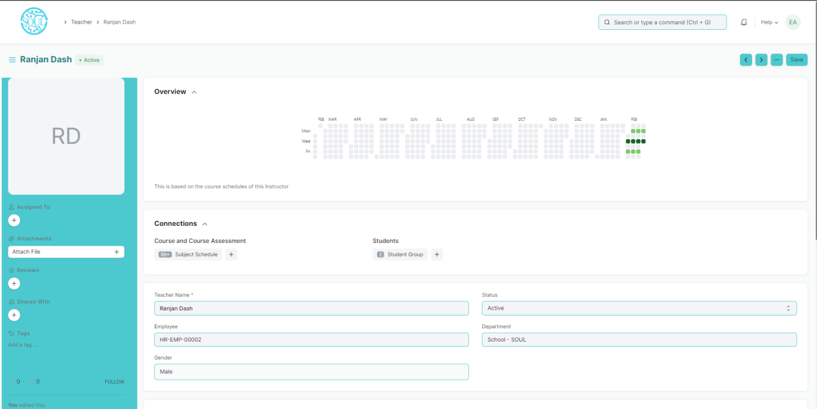Student Group

#### How to create an Teacher?

1. Click on New Teacher.
2. Select the Employee ID/Employee Name for the Teacher.
3. Select the Department for which you are creating a Teacher.
4. Save.

#### Features

* Teacher Log
* Academic Year: The Academic Year for which the Teacher is created.
* Department: The department to which the Teacher belongs to.
* Class: The Class for which the Teacher Log is being made.
* Subject: The Subject for which the Teacher Log is being made.
* Student Group: The Student Group for which the user is making the Teacher Log.
* Other Details: Any other details regarding the Teacher Log can be recorded here.
* After Submitting

Once the Teacher and Teacher Log is saved, you can create the following from there:

1. Student Group
2. Subject Schedule
3. Assessment Plan

***Note: While creating an Evaluation Plan from the Teacher, the user can select whether the Teacher has to be kept as a Moderator or as an Paper Setter for the Evaluation plan.

1. Guardian

Guardian allows you to record the details of the Guardians of a Student.

Every student can have multiple guardians like Father, Mother, Brother, or Sister.

To access Guardian, go to:

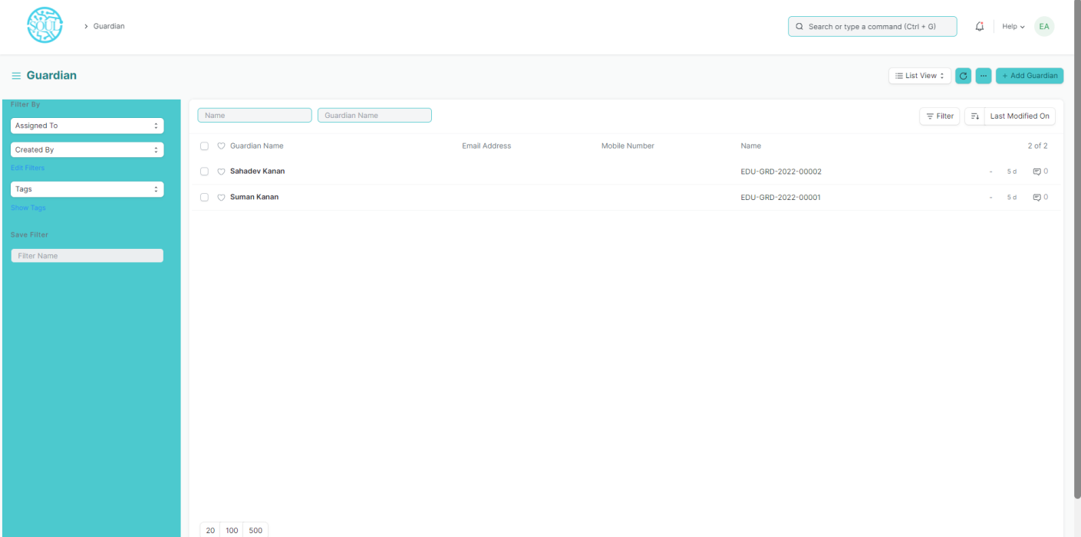Home > School-Education > Student > Guardian

#### Prerequisites

Before creating a Guardian, it is advised to create the following first:

* Student
* User

#### How to create a Guardian?

1. Click on New Guardian in the Guardian List.
2. Add the name of the Guardian and click on Save.

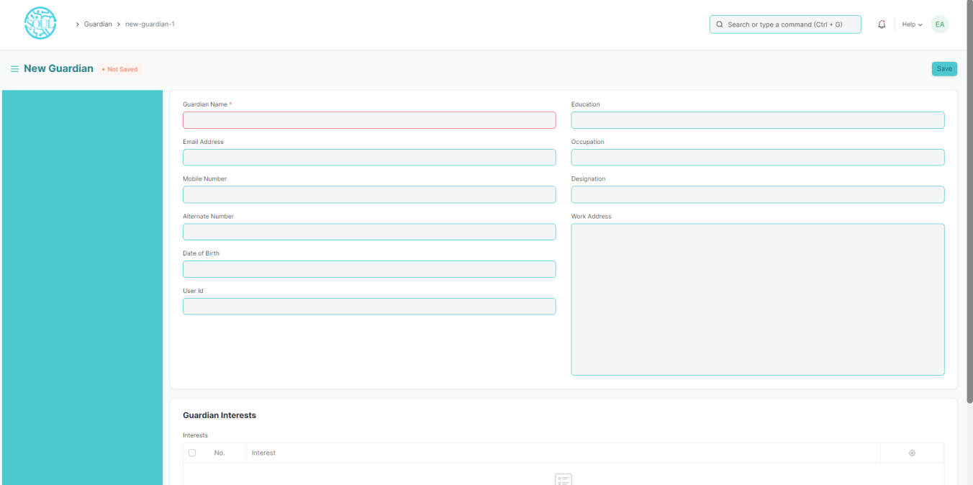

#### Additional Options while creating a Guardian

Apart from the mandatory details of the Guardian, you can also add the following details:

1. **Email Address:** Enter the email address of the Guardian. The email address can be linked to an email group for sending Newsletters or Announcements.
2. **Mobile Number:** The mobile number of the Guardian can be recorded here.
3. **Alternate Mobile Number:** You can add the Alternate Mobile Number of the Guardian over here for emergency purposes.
4. **Date of Birth:** The date of birth of the Guardian can be recorded here.
5. **User ID:** If the Guardian is a User of the system, their User Id can be mentioned here.
6. **Education:** The Academic and Educational details of the Guardian can be recorded here.
7. **Occupation:** The occupation of the Guardian can be captured here.
8. **Designation:** You can enter the designation of the Guardian here.
9. **Work Address:** The Work Address of the Guardian can be recorded here for emergency purposes.

#### Features

* 1. **Guardian of Students**

While creating a Student, if you have selected a Particular Guardian for them, the name of that Student will automatically be fetched here. Multiple students can have the same person as their guardian. In that case, multiple entries will be made in this section. However, on the front end, one will not be able to add more students to this section.

* 1. **Making the Guardian a User**

Once Guardian has been saved, you can find a button Invite as User on the top right corner of the form. This button would allow you to invite the guardian as a User of EduLead by sending them an invitation email on the recorded email ID.

#### Related Topics

Student

1. Student Categories

Student Categories allows you to classify the students based on various categories.

In Institutions, there may be fee concession for some categories such as Handicapped Students, Foreign Nationals, Reserved Categories by the government, etc.

When a Student is enrolled for a Class, you can select the select the Category for the Student.

To access Student category, go to:

Home > School-Education > Settings > Student Category

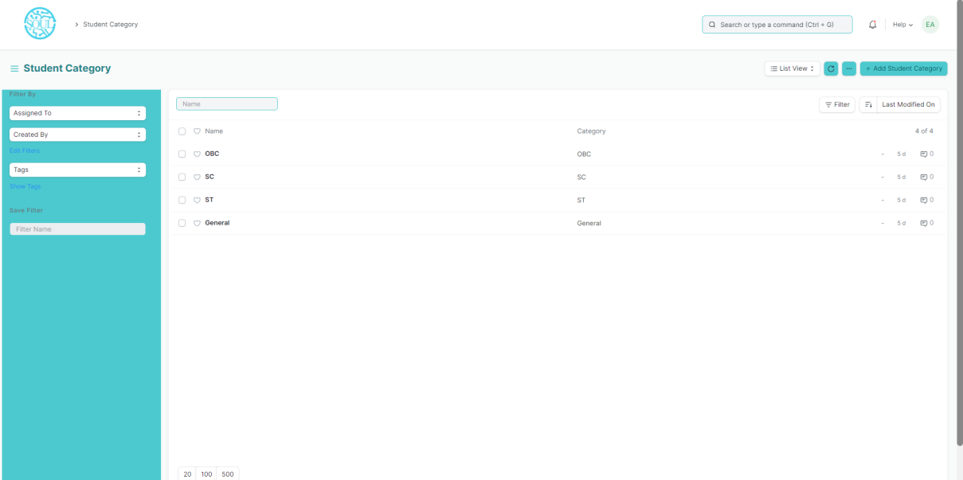

#### How to create a Student Category?

To create a new student category, click on New Student Category and add the name of the Student Category.

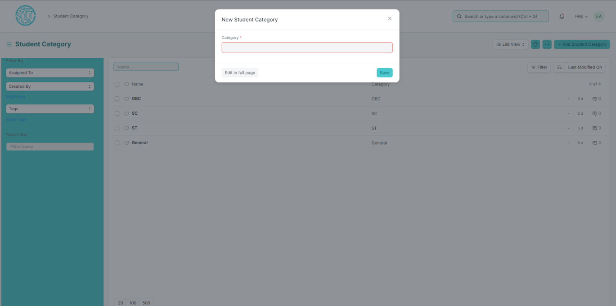You can select the Student Category while making the Fee Structure and accordingly the student from the selected groups can be filtered out while making the Fee Schedule.

## 

1. Student Batch

A Student batch is a collection of students from within Student Groups.

For example, a group of students studying the same Class together will be called a Student Batch.

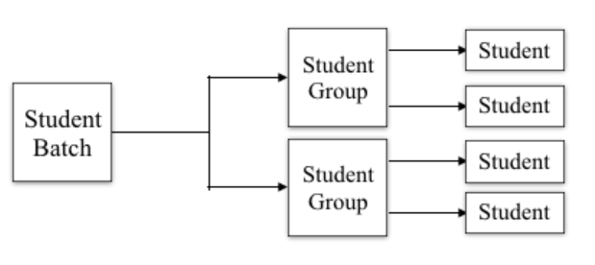To access the Student Batch, go to:

Home > Education > Settings > Student Batch Name

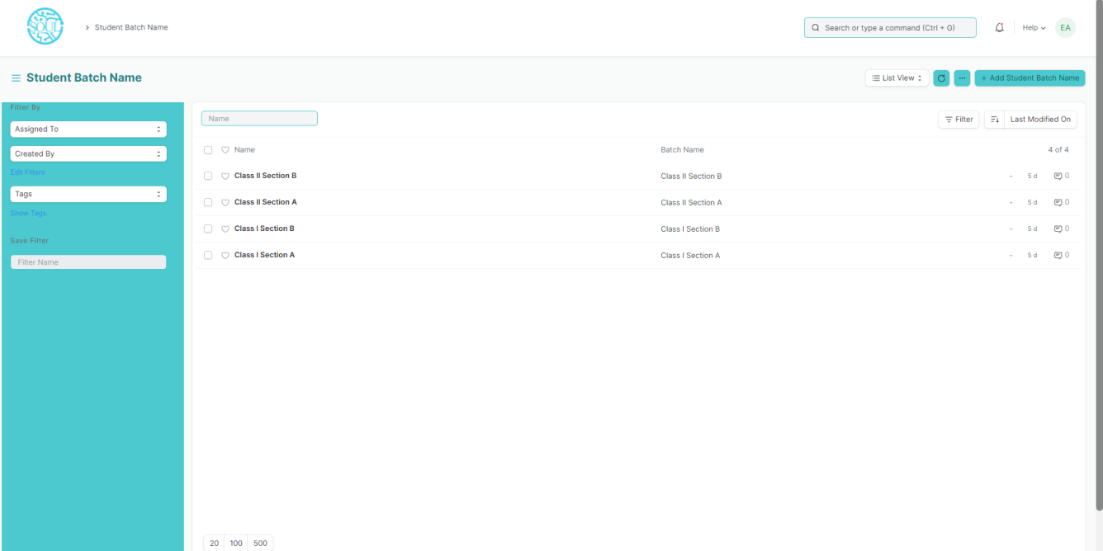When a student is enrolled for a Class, the batch can be selected for the student, and they shall be a part of that batch.

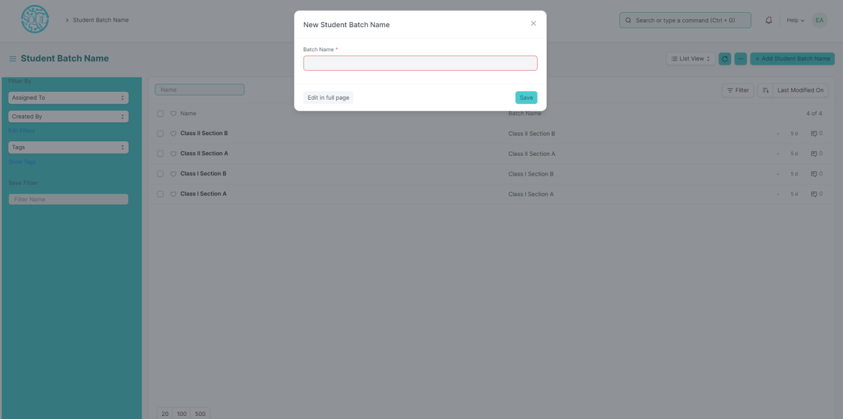You can also get a Student Batch-Wise Attendance report to view the number of students present from the Batch.

#### How to create a Student Batch?

1. Click on Add Student Batch Name.
2. Enter the Batch Name.
3. Save

## Admission Masters

## **3.1 Document Template**

Document Template is a list of all the different templates required for getting admission in a particular class. Document Template is primarily used while creating a student admission for a class.

To access Academic Events, go to:

Home > School-Admission > Admission Masters > Document Template

Prerequisite:

* Academic Year
* Student Category
* Documents

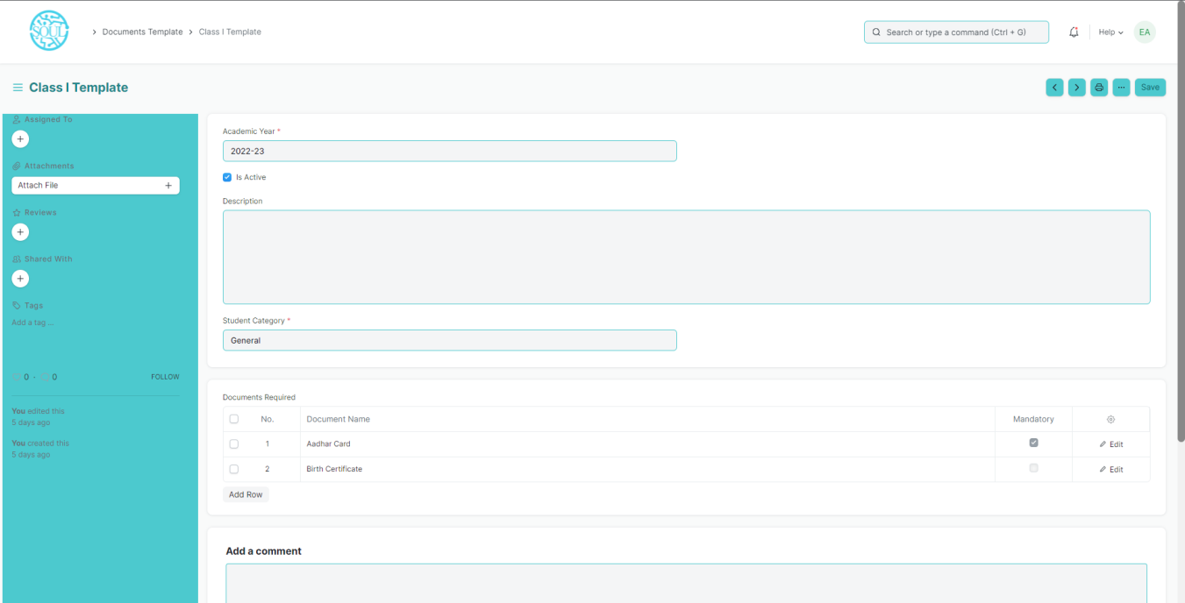

#### How to create a Document Template?

#### Click on Add Documents Template.

#### Add Template Name, Academic Year.

#### Check Is Active button.

#### Add Description.

#### Select Student Category from the list of dropdown that appears.

#### In the Document Required Table add all the different Documents.

#### Save.

## **3.2 Academic Events**

An Academic Events are individual events which is used for creating Academic Calendar while preparing Schedule for a Class.

To access Academic Events, go to:

Home > School-Admission > Admission Masters > Academic Events

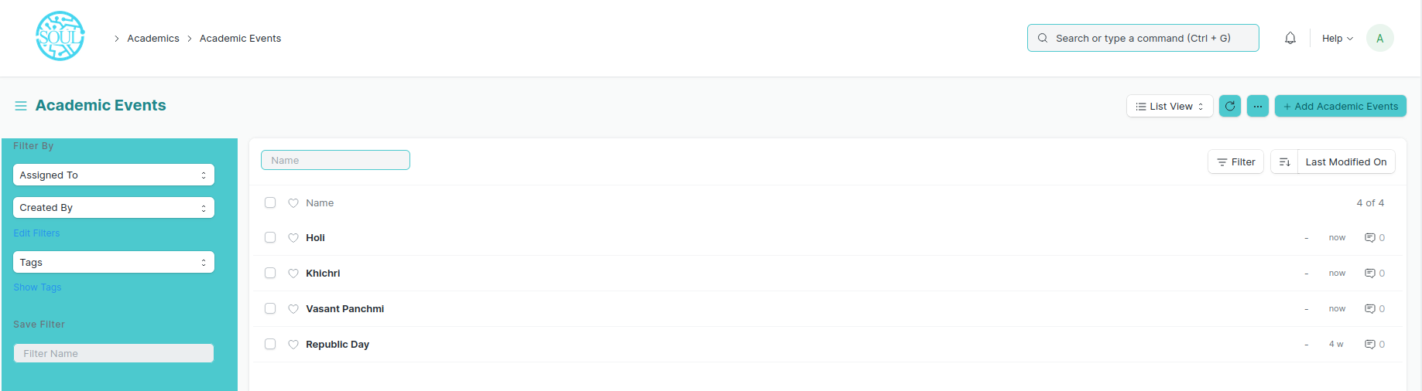

#### How to create an Academic Event?

1. Click on Add Academic Events.
2. Add Event Name.
3. Save.

## **3.3 Academic Calendar Template**

Academic Calendar Template is a list of all different events that will be happening in an Academic year for a particular class.

For Every Class a separate Academic Calendar Template will be created and later be linked while declaring admission for that class.

To access Academic Events, go to:

Home > School-Admission > Admission Masters > Academic Calendar Template

Prerequisite:

* Academic Year
* Class
* Academic Events

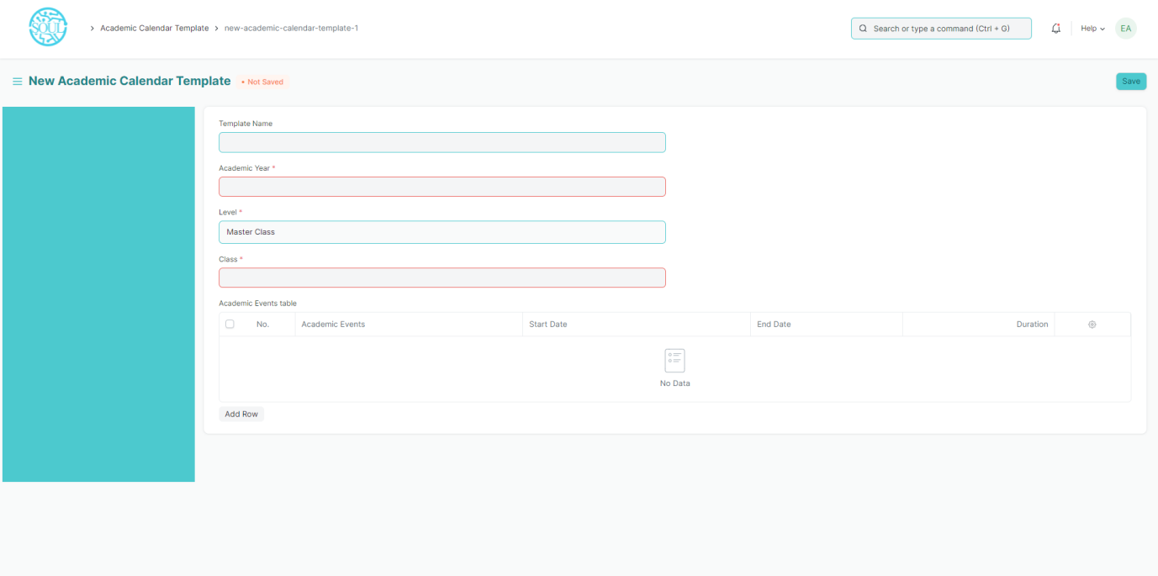

#### How to create an Academic Calendar Template?

1. Click on Add Academic Calendar Template.
2. Add Template Name.
3. Select Academic Year and Class from the List that appears on clicking on those fields.
4. Select Academic Events and add Starting date, End date for the events.
5. Save.

## **3.4 Eligibility Parameter**

An Eligibility Parameter is a label based on which Students eligibility is checked while defining Student admission.

To access Academic Events, go to:

Home > School-Admission > Admission Masters > Eligibility Parameter

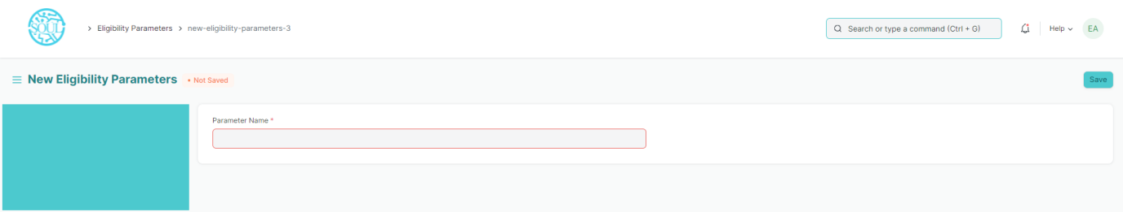

#### How to create a Eligibility Parameter?

1. Click on Add Eligibility Parameter.
2. Add Parameter name.
3. Save.

### 3.5 Academic Year

An academic year is a period which the Educational Institutes, Schools and Universities use to measure a quantity of study.

The Academic year form have the Start and End date for the Academic year. Within an Academic Year, you can have multiple Academic Terms. An academic Year can be further liked to a Student Group, which can be created from an Academic Year.

If the Academic Year has been specified in the Education Settings, then it will become the default Academic Term in all the forms and will be editable if required.

To go to Academic Year, go to:

Home > School-Admission > Admission Masters > Academic Year

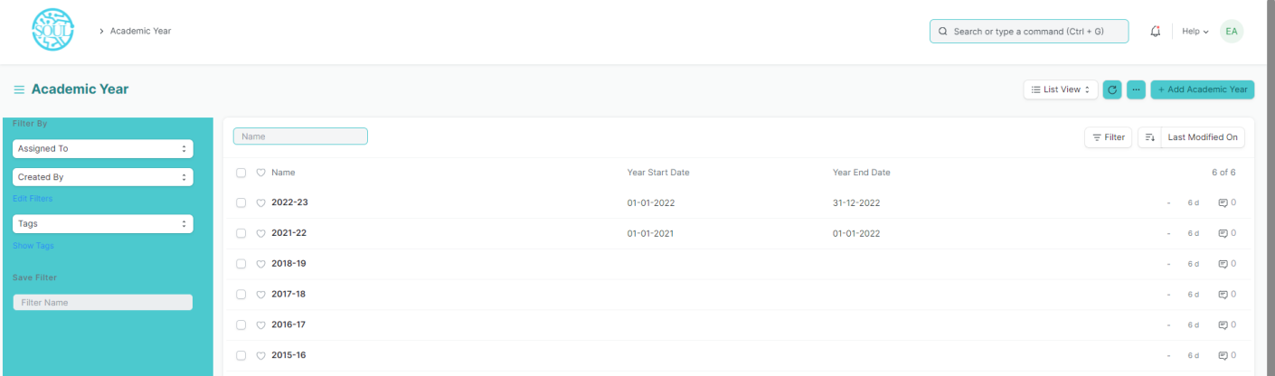The following are the various forms where Academic Year is a relevant field:

1. Student Log
2. Student Group
3. Student Applicant
4. Student Admission
5. Class Enrollment
6. Assessment Plan
7. Assessment Result
8. Assessment Criteria
9. Fees
10. Fee Schedule
11. Fee Structure
12. Fee Category
13. Subject Schedule

## Application & Enrollment

4.1 Student Admission

Student Admission is a document which can be configured to initiate an Admission Process for your institution by publishing it on the website.

To access student Admission, go to:

Home > School-Admission > Application and Enrollment > Student Admission

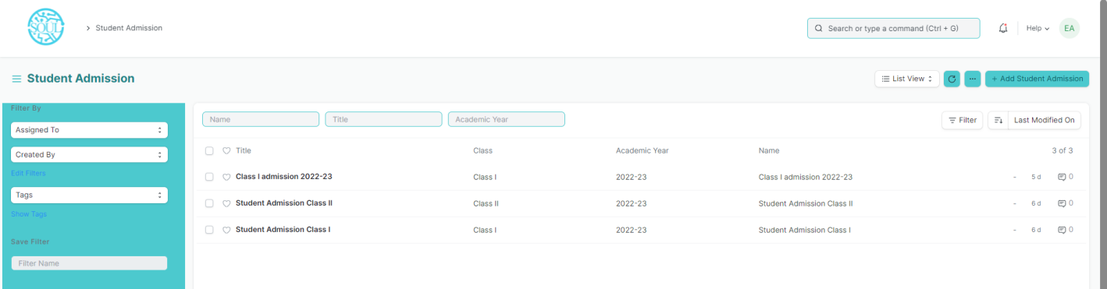

#### Prerequisites

Before creating a Student Admission, it is advisable that you first create the following:

1. Academic Year
2. Class
3. Academic Calendar
4. Student Category
5. Document Template
6. Parameter

#### How to create a Student Admission?

1. Go to Student Admission list and click on New.
2. Enter Title.
3. Select Class, Academic Calendar, Academic Year.
4. Enter Total Seats, Enrollment start date, Enrollment end date, Eligibility details, Eligibility Parameter List, Introduction.
5. Select If Admission Fees is Applicable or not.
6. Save.

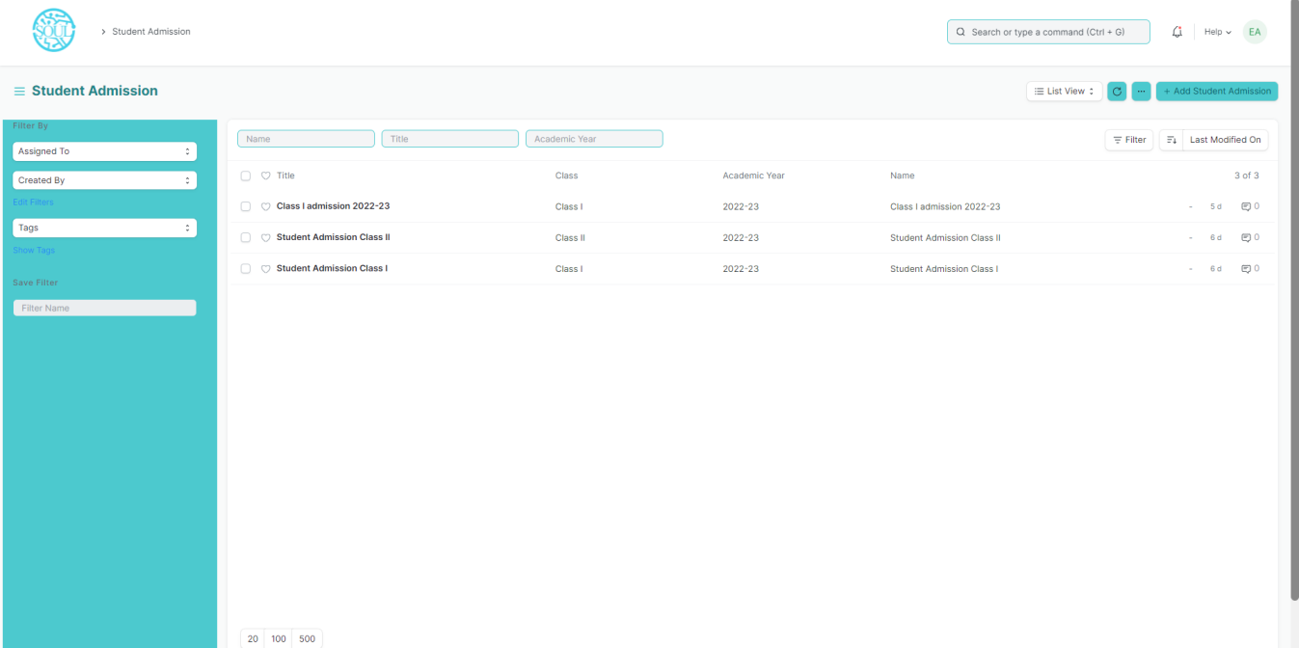

#### Eligibility and Details

* Class: Here you can select which Class are the admissions being called for.
* Application Fee: You can choose to declare the application fee for the selected Class.

**Introduction: You can add a brief introductory information about the admission process so that it is better understood to the admission seekers. **

4.2 Student Applicant

A Student Applicant record gets created when a student applies to your institute for admission.

You can Approve or Reject a student applicant. By accepting a student applicant, you can add them to the student master.

To access student Applicant, go to:

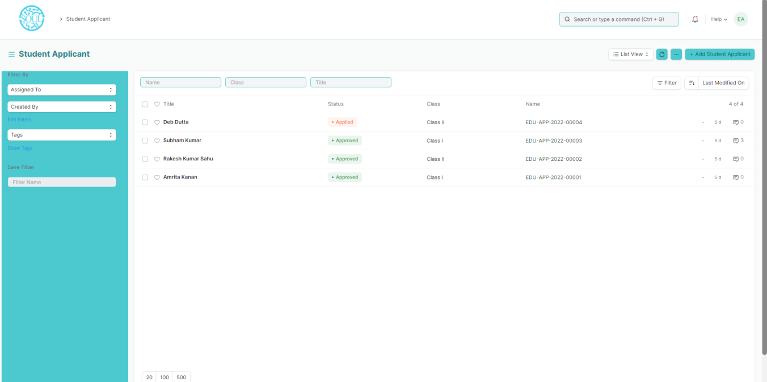Home > School-Admission >Application and Enrollment > Student Applicant

#### Prerequisites

Before creating a Student Applicant, it is advisable to first create the following:

1. Academic Year
2. Student Admission
3. Student Category

#### How to create a Student Applicant?

1. Go to the student Applicant and click on New.
2. Enter the First Name of the student Applicant.
3. Enter the Class for which the student has applied.
4. Enter the Student Email Address.
5. Save.

#### Features

**Online Application via a Web Form**

A Student Applicant gets automatically created when a student applies online. This can be made possible through the Student Applicant Web Form which is created by default in the system. Search for "Web Form List" in the awesome bar to access the list of all the web forms in the system.

Once the student applies, the status of the application by default is "Applied". You can either "Approve" or "Reject" the form.

Once the application is approved, you can "Enroll" the student to a Class.

***Note: Once a student is created against the student applicant, the system will set the application status to 'Admitted' and will not allow you to change the application status unless the student record is deleted.

4.3 Class Enrollment

Class Enrollment is the record of enrollment of a student in a given Class and chosen Subjects for a particular Academic year.

To ensure that students are associated with a particular Class in the system, their Class Enrollment must be created. The mandatory Subject in that Class is automatically filled in the Enrolled Subjects table while the elective or optional Subjects can be selected manually.

To access Class Enrollment, go to:

Home > School-Admission > Application and Enrollment > Class Enrollment

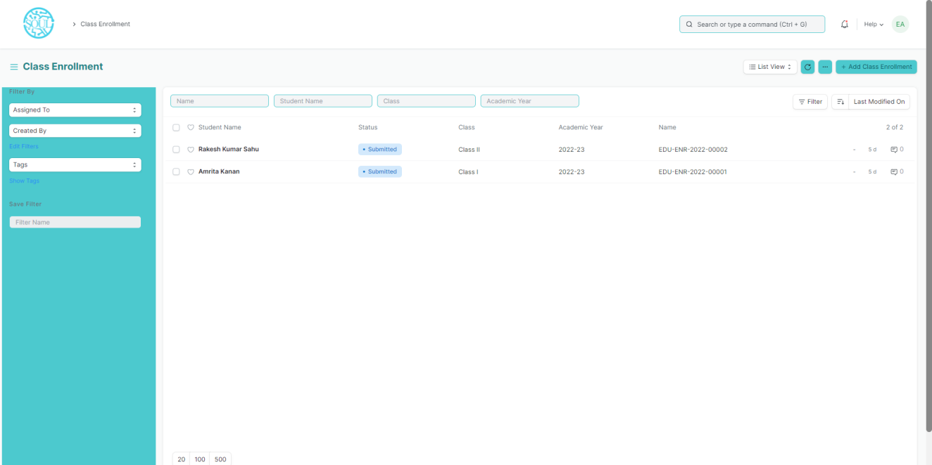

#### Prerequisites

Before creating a Class Enrollment, it is advisable that you create the following first:

1. Student
2. Class
3. Section
4. Class Teacher
5. Class Coordinator
6. Student Category
7. Student Batch
8. Academic Year
9. Subject
10. Academic Calendar

#### How to create a Class Enrollment?

1. Go to Class Enrollment List and click on new.
2. Select the Student whom you are getting enrolled in the Class.
3. Select the Class under which you are getting the student enrolled.
4. Enter the Academic Year for which the student is getting enrolled.
5. The Enrollment Date for the form would by default be set on the current date, the same, however, can be changed if needed.
6. 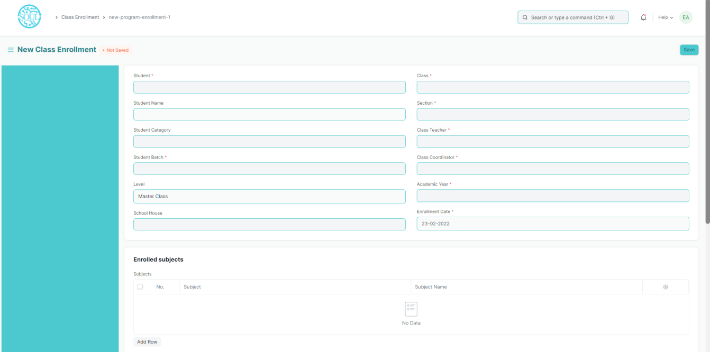Save and submit.

#### Additional Options while creating a Class Enrollment

1. Student Category: Select the category if the student belongs to a particular student category.
2. Student Batch: Select the batch if the student belongs to a particular student batch.
3. Student House: Select the House if the student belongs to a particular student house.

#### Features

* **Enrolled Subjects**

Select and add the Subjects which the student has opted to study during the Subject of the Class.

4.4 Subject Enrollment

Subject Enrollment is the record of enrollment of a student in a given Class and chosen Subjects for a particular Academic Year.

To ensure that students are associated with a particular Class in the system, their Subject Enrollment must be created/auto-generated. The mandatory Subject in that Class is automatically filled in the Enrolled Subjects table while the elective or optional Subjects can be selected manually.

To access Subject Enrollment, go to:

Home > School-Admission > Application and Enrollment > Subject Enrollment

## 5. Fees

* 1. Fee Structure

A Fee Structure is a template that can be used while making Fees records or generating them via the Fee Schedule.

The Fee structure can be fetched while creating the [Fees](https://docs.erpnext.com/docs/v13/user/manual/en/education/fees) for each student.

To access Class Enrollment, go to:

Home > School-Admission > Fees > Fee Structure

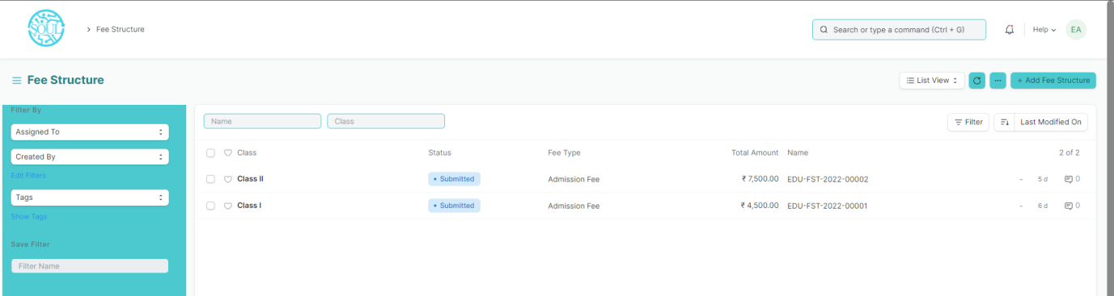

#### Prerequisites

Before creating a Fee Structure, it is advisable that you create the following first:

1. Class
2. Academic Year
3. Fee Type
4. Fee Category

#### How to create a Fee Structure?

1. Go to Fee Structure List and click on new.
2. Select Class, Academic Year, Student Category, Fee Type.
3. Add Fee Category and Amount in the Components table.
4. Save.

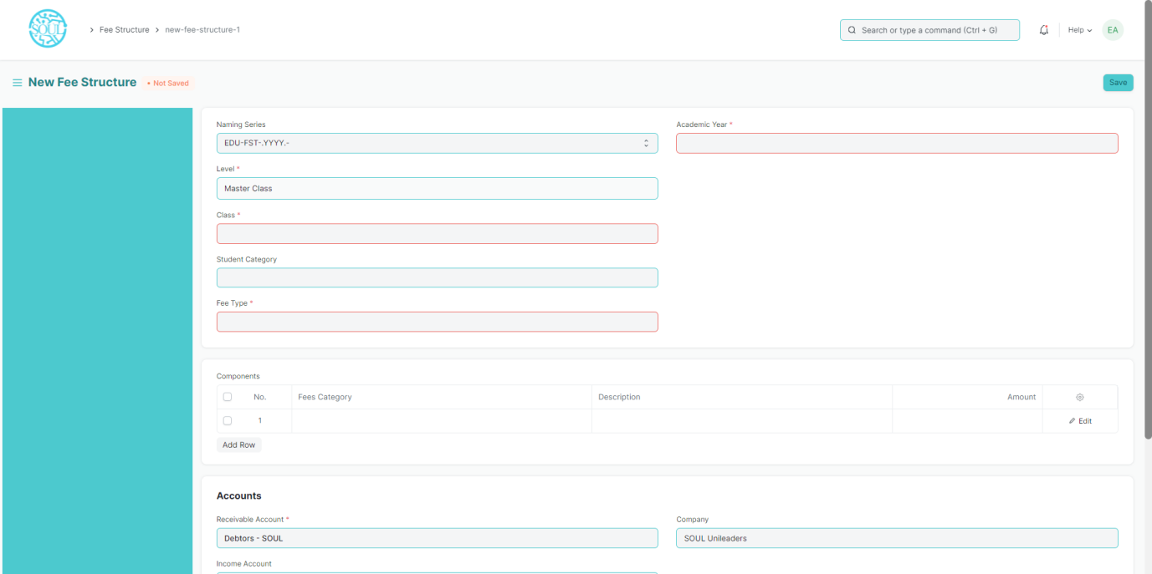

* 1. Fee Schedule

Fee Schedule would help you in defining a time-line for the Fee payment of the students, based on the Student Group.

To access Fee Schedule, go to:

Home > School-Admission > Fees > Fee Schedule

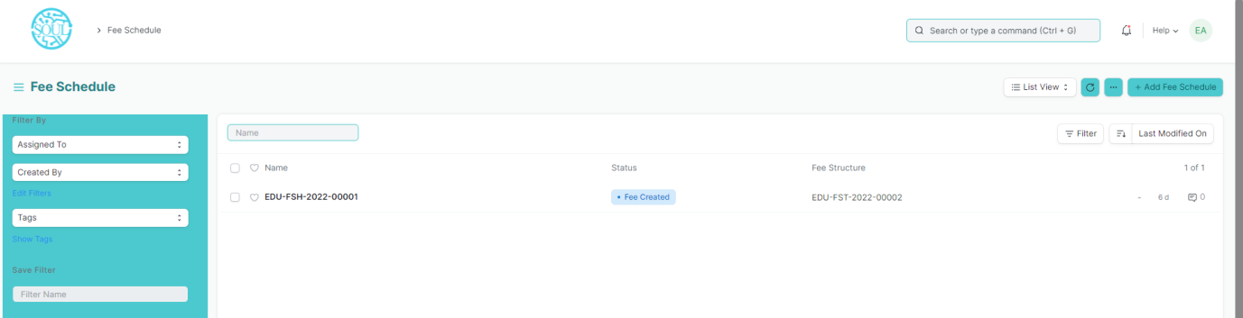

#### Prerequisites

Before creating a Fee Schedule, it is advisable that you create the following first:

1. Fee Structure
2. Student Group

#### How to create a Fee Schedule?

1. Go to Fee Schedule List and click on new.
2. Select Fee Structure.
3. Add Due date.
4. Select Student Group
5. Save.

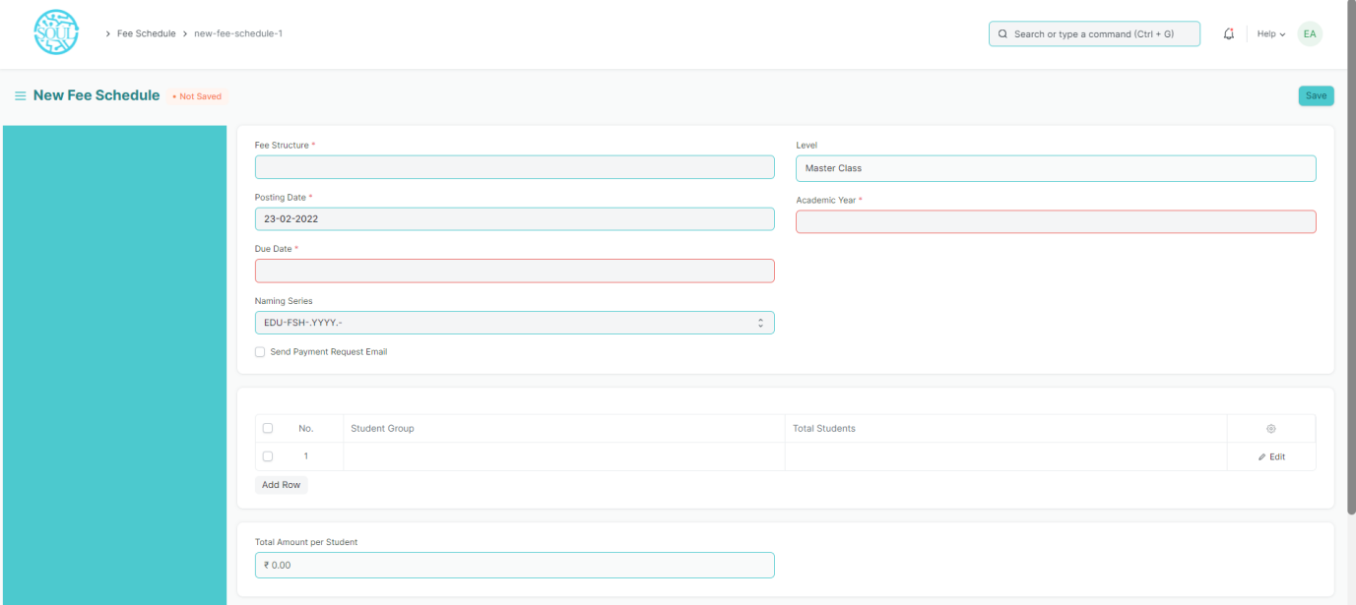

* 1. Fee Category

Fee Category would form all the components for calculation of Fees or creation of Fee Structure.

For example, Tuition Fees and Hostel fees would make the different categories of fees.

To access Fee Schedule, go to:

Home > School-Admission > Fees > Fee Category

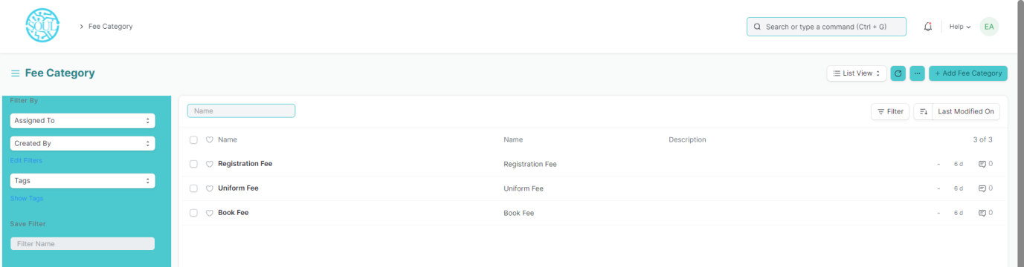

#### How to create a Fee Category?

1. Go to Fee Category List and click on new.
2. Enter Fee Category Name.
3. Save

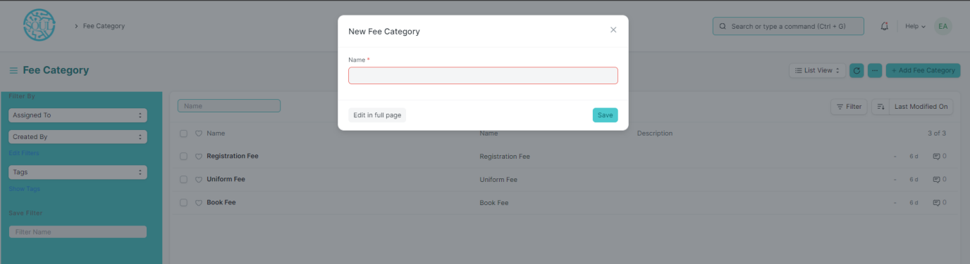

* 1. Fees

By Creating Fees we can maintain the Fee Records of the students.

At the time of submission of Fees by each student, a new Fees Record will be created wherein all the details of the student, Class they are enrolled in, Accounting information, etc. would be maintained.

To access Fee Schedule, go to:

Home > School-Admission > Fees > Fees

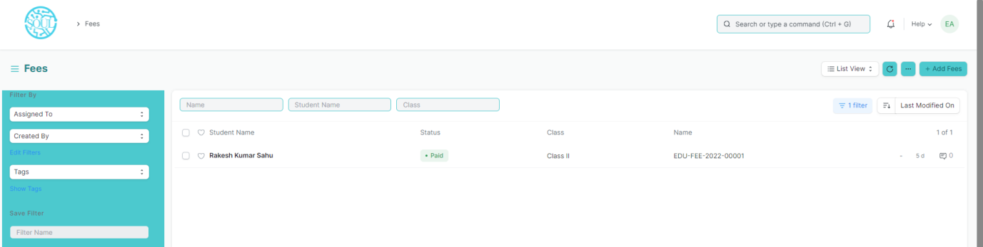

#### Prerequisites

Before creating a Fee Schedule, it is advisable that you create the following first:

1. Student
2. Fee Category
3. Fee Structure

#### How to create a Fees?

1. Go to Fee Category List and click on new.
2. Select Student, Due Date, Valid from, Valid to.
3. Select Fee Structure
4. Add Receivable Account.
5. Save.

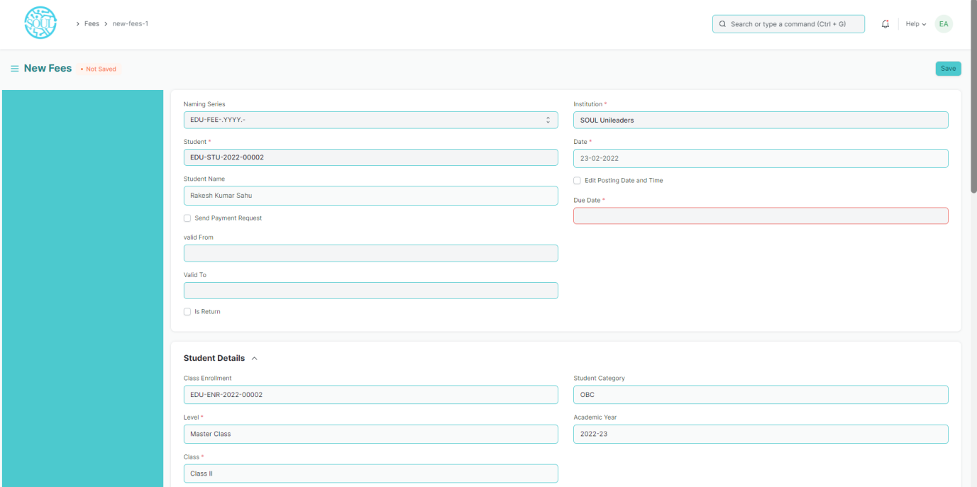

## Tools

* 1. Student Reregistration Tool

Students Reregistration tool is a tool for Reregistering the students once they have completed the examination and there is a need to promote the entire group of students to the next class.

To access Fee Schedule, go to:

Home > School-Admission > Tools > Student Reregistration Tool

#### Prerequisites

#### Before using the Student Reregistration tool, it is advisable that you create the following first:

1. Class
2. Section
3. Class Teacher
4. Class Coordinator
5. Academic Year

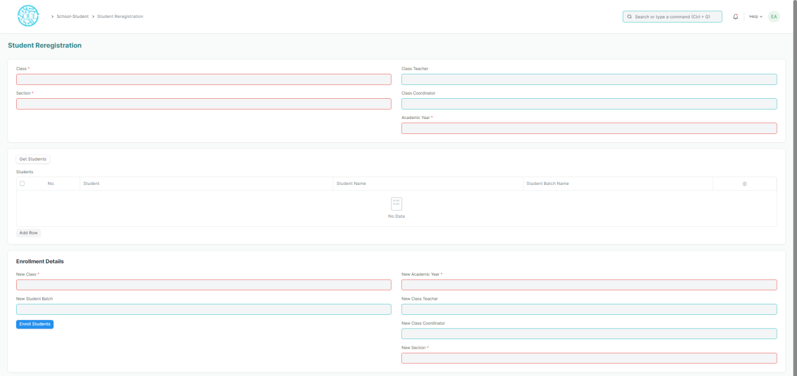

#### How to use Student Reregistration Tool?

1. Open Student Reregistration Tool.
2. Select Class, Section, Class Teacher, Class Coordinator, Academic Year.
3. Click on the Get Student button and all the student for that class will be fetched in the table.
4. Select New Class, New Student Batch, New Academic Year, New Class Teacher, New Class Coordinator, New Section.
5. Click on Enroll Students button.